SUPPLEMENTARY MATERIAL

Supplementary Table 1. Risk of bias assessment based on ACROBAT-NRSI¹
Study，publication year | Bias due to confounding | Bias in selection of  participants | Bias in  measure  ments of  interventions | Bias due to  departures from  intended  interventions | Bias due to  missing  data | Bias in  measure  ments of  outcomes | Bias in  selection of  reported  result | Overall bias
Peng J,2015¹⁷ | N | N | N | N | N | PN | N | Low
Buti M,2015¹⁸ | Y | PY | N | N | N | N | N | Serious
Fontaine H,2015¹⁹ | Y | PY | N | N | N | N | N | Serious
Chen L,2015²⁰ | N | N | N | N | PN | N | N | Low
Hsu YC,2016²¹ | N | PN | N | N | N | N | N | Low
Park CH,2016²² | PY | PY | N | N | N | PY | PY | Serious
Jun BG,2016²³ | N | PN | PN | PN | N | N | N | Moderate
Lin CC,2016²⁴ | N | N | N | N | PN | PY | PY | Serious
Nagata N,2016²⁵ | N | N | N | PN | N | PY | PN | Serious
Lee HA,2016²⁶ | N | N | PN | N | PN | N | N | Moderate
Siederdissen CH,2016²⁷ | PN | PN | N | N | N | N | PN | Moderate
Siederdissen CH,2016²⁸ | PY | PN | N | N | N | N | PY | Serious
Muche M,2017²⁹ | PN | PY | N | N | N | N | PN | Serious
Karakaya F,2017³⁰ | N | N | PN | N | N | N | N | Low
Cao JW,2017³¹ | N | N | PN | N | PN | N | N | Moderate
Berg T,2017³² | N | N | PN | PN | N | N | N | Moderate
Jeng WJ,2018³³ | PY | N | N | PN | N | N | PN | Serious
Dalekos GN,2018³⁴ | N | N | PN | PN | PN | N | N | Moderate
Papatheodoridis GV,2018³⁵ | N | N | PY | PN | N | N | N | Serious
Rivino L,2018³⁶ | PN | N | PY | PN | PN | N | N | Serious
Chi H,2018³⁷ | PN | N | PN | N | N | PN | N | Moderate
Liu F,2018³⁸ | N | PN | N | PN | N | N | N | Moderate
Hsu YC,2018³⁹ | N | N | PY | PY | N | N | PN | Serious
Kranidioti H,2019⁴⁰ | PY | PY | PN | N | PN | N | N | Serious
Hees SV,2019⁴¹ | PY | PN | PN | PN | N | PY | N | Serious
Xie LQ,2019⁴² | PN | N | N | PN | N | PN | N | Moderate
N: no, PN: probably no, PY: probably yes, Y: yes.
Reference
[1] Sterne JAC, Higgins JPT, Reeves BC; on behalf of the development group for ACROBAT-NRS. A Cochrane Risk of Bias Assessment Tool: For Non-Randomized Studies of Interventions (ACROBAT-NRSI), version 1.0.0, September 24, 2014. http://www.riskofbias.info. Accessed Aug 2019.

SUPPLEMENTARY FIGURE LEGENDS
Supplementary Figure 1. Flow chart of study search and selection
Supplementary Figure 2. Forest plots of overall probabilities of biochemical relapse (BR) afeter NAs cessation. A: All patients, B: HBeAgpositive patients, C: HBeAg-negative patients. ES means effect size, which refers to estimated probability.
Supplementary Figure 3. The rates of off-NAs biological relapse (BR) during follow-up after NAs cessation. A: All patients, B: HBeAg-positive patients, C: HBeAg-negative patients. Bars are 95% CI. Green lines are trend lines.
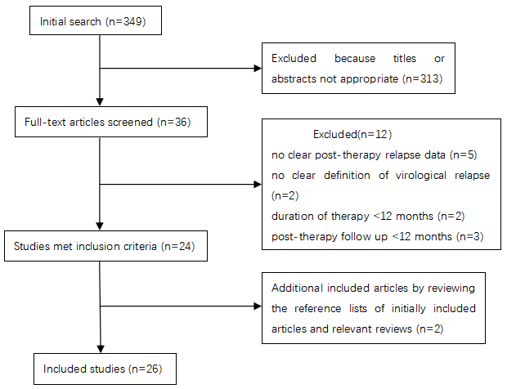
Supplementary Figure 1. Flow chart of study search and selection

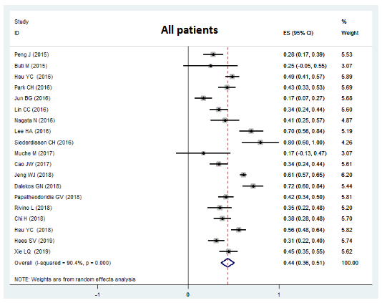
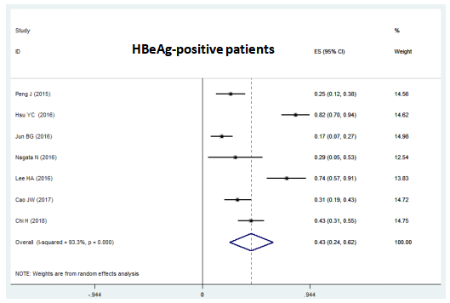
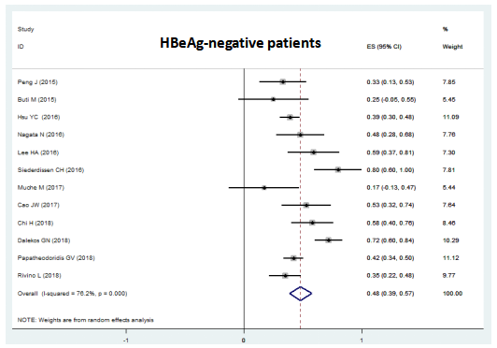
Supplementary Figure 2. Forest plots of overall probabilities of biochemical relapse (BR) afeter NAs cessation. A: All patients, B: HBeAgpositive patients, C: HBeAg-negative patients. ES means effect size, which refers to estimated probability.

Supplementary Figure 3. The rates of off-NAs biological relapse (BR) during follow-up after NAs cessation. A: All patients, B: HBeAg-positive patients, C: HBeAg-negative patients. Bars are 95% CI. Green lines are trend lines.

